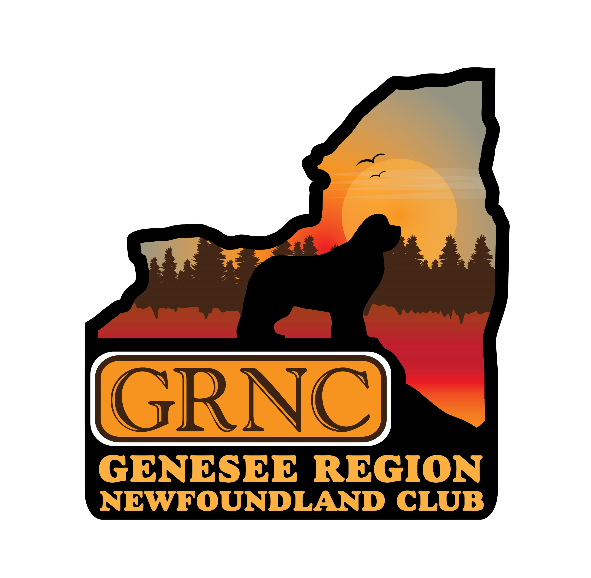

**GRNC RENEWAL OF MEMBERSHIP**

**CLUB YEAR March 31, 2025 – April 1, 2026**

NAME:

_____________________________________________________________

ADDRESS:

_____________________________________________________________

TELEPHONE NUMBER: _____________________________________________________________

EMAIL ADDRESS: _____________________________________________________________

***What’s Newf***, the club newsletter, and all club correspondence will be distributed via email unless the member indicates to the newsletter editor a preference to receive via USPS. Editor: Anne Smith Abbey email: aesmithabbey@hotmail.com

ARE YOU A MEMBER OF THE NCA: YES OR NO (PLEASE CIRCLE)

DONATION TO BROWN BAG AUCTION FUND __________________________

This fund has been set up to purchase items for our Brown Bag Auction Fundraisers.

**MEMBERSHIP MUST BE RENEWED NO LATER THAN APRIL 1, 2025**

ANNUAL MEMBERSHIP RATES:

SINGLE $30

FAMILY $35

NEWSLETTER ONLY $20

MAIL THIS FORM ALONG WITH CHECK OR MONEY ORDER PAYABLE TO GRNC TO:

JODY AYERS, GRNC TREASURER

946 STATE ROUTE 369

CHENANGO FORKS, NY 13746